Design Document - Team Gold Squadron

Software:

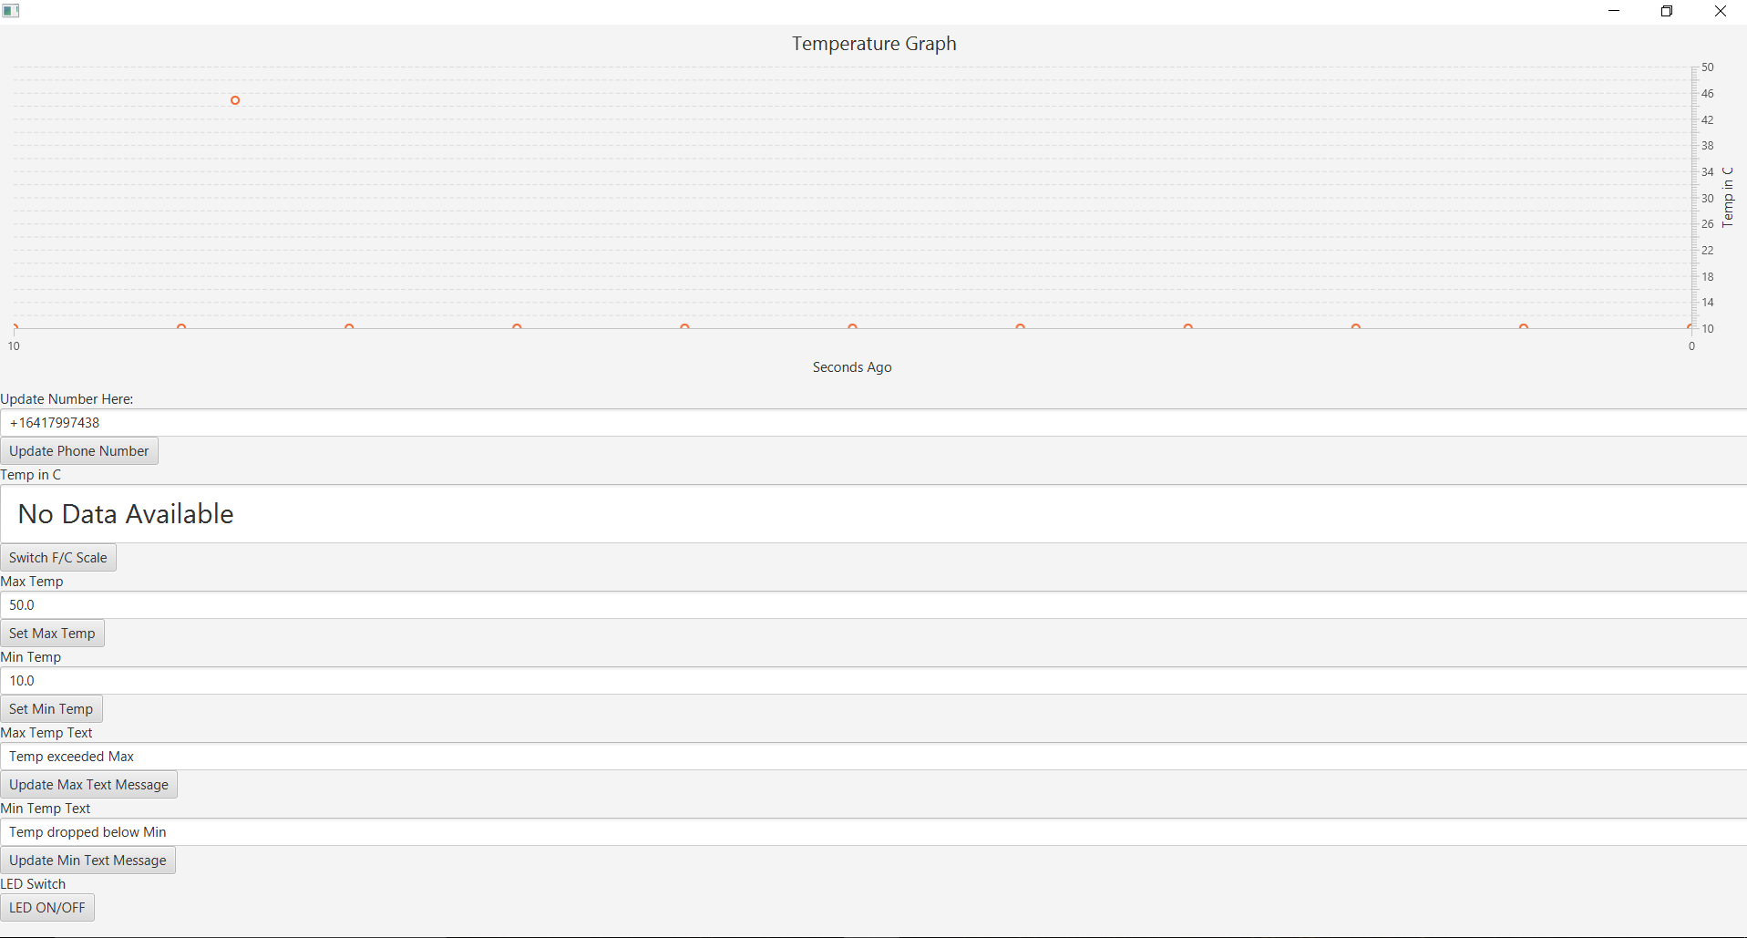

The Design for the software component was set up using a simple java program. We created an interface using JavaFX to display all the necessary information. The first thing we added was a graph to display the real time temperatures as they come in from the temperature sensor connected to the arduino.

Next we added buttons and text boxes for the user to interact with. First is a phone number box that allows you to change the recipient of the warning texts when the temperature is not within the min and max bounds that you set. The next box is a temperature box that displays the current temperature of the thermometer. In our design, we added functionality to the temperature button that switches the displayed temperature between Celsius and Fahrenheit. If for some reason the thermometer becomes unplugged, we programmed the temperature textbox to display “unplugged sensor”. Also, if the button on the arduino is pressed to off, the temperature textbox would display “No Data Available”.

The next two text boxes to add are to control the temperature settings for the max and min temperatures. These boxes control the threshold for what temperature value makes the warning text messages send. After that are the two boxes that determine the content of the messages that are sent. You are able to update them to personalize the message that is sent when a temperature exceeds the min or max threshold. Lastly, add an LED switch that simulates the same functionality of pressing the button on the arduino. By pressing this button on the interface, the LED display would be turned on and off. Each of the buttons need to be programmed with action listeners that will run through the functionality described above when they are pressed.

Transferring information between the Arduino and Java Application utilizes RXTX communication through a Fire Wire that runs from the Arduino to the computer running the software. The Class named Arduino has a connection method which allows the program to choose what port to read and write from as well as a baud rate that should match the baud rate set on the Arduino.

For the sending texts part of our thermometer, we used Twilio, which is a company API for messaging, voice, video and authentication to make the programmable communication. We signed up on Twilio to buy a virtual phone number for our thermometer, so all messages about the thermometer and temperature will be sent from that phone number. Then we created a java method called sendSMS which is used in our main class when all conditions are certified to send a text message. There are two string arguments to pass to this method. The first one is the phone number to receive the messages, and the second one is the body of the message. These two strings are able to be modified. We also needed to add Twilio JAVA Helper Library to our java project. It allowed us use methods to communicate our java project with Twilio. When the computer is on and the third box is on, a text message will be sent to a specified phone number whenever the real time temperature exceeds the min and max bounds.

Software References:

-Thermometer libraries website  
<http://www.hobbytronics.co.uk/ds18b20-arduino>

"Arduino - One Wire Digital Temperature Sensor - DS18B20." HobbyTronics | Hobby Electronics Components Supplier for Your Hobby and Education Needs, OpenCart, www.hobbytronics.co.uk/ds18b20-arduino. Accessed 12 Sept. 2017.  
In‑text: ("Arduino - One Wire Digital Temperature Sensor - DS18B20"  
  
-Step-by-step guide on Thermometer to Arduino  
<https://create.arduino.cc/projecthub/TheGadgetBoy/ds18b20-digital-temperature-sensor-and-arduino-9cc806>

Dimitrov, Konstantin. "DS18B20 (digital Temperature Sensor) and Arduino." Arduino Project Hub, Arduino, 22 Nov. 2016, create.arduino.cc/projecthub/TheGadgetBoy/ds18b20-digital-temperature-sensor-and-arduino-9cc806. Accessed 10 Sept. 2017.  
  
-Graphing tutorial from Oracle  
<http://docs.oracle.com/javafx/2/charts/chart-overview.htm>  
Redko, Alla. “Release: JavaFX 2.2.” Using JavaFX Charts: Introduction to JavaFX Charts | JavaFX 2 Tutorials and Documentation, Oracle, 6 Dec. 2013, docs.oracle.com/javafx/2/charts/chart-overview.htm. Accessed 25 Sept. 2017.  
  
-Adding Libraries to netBeans  
<https://stackoverflow.com/questions/3737051/how-to-set-the-netbeans-boot-class-path-to-include-mail-jar>

-Java Library for RXTX Communications  
<https://github.com/HirdayGupta/Java-Arduino-Communication-Library/wiki/Instructions>

Gupta, Hirday. “HirdayGupta/Java-Arduino-Communication-Library.” GitHub, 3 Nov. 2016, github.com/HirdayGupta/Java-Arduino-Communication-Library/wiki/Instructions.  
  
-Arduino Guide for RXTX Communications  
<https://www.arduino.cc/en/Serial/Write>

Arduino - Write, Arduino, www.arduino.cc/en/Serial/Write. Accessed 25 Sept. 2017.

Hardware:

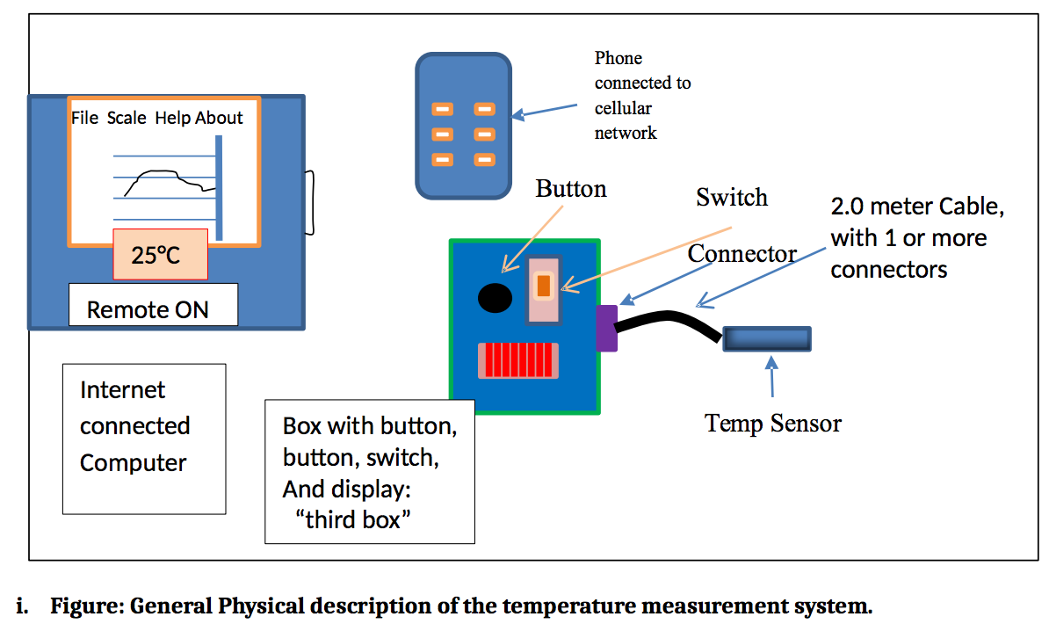

(Figure 1: The provided design schematic for the complete thermometer system)

The design of the hardware component of the Thermometer System is called the “Third Box” which contains the microcontroller (MCU) and all of the subsequent wiring along with a power switch, a process button, and the seven LED system that displays the corresponding temperature in 7-bit binary.

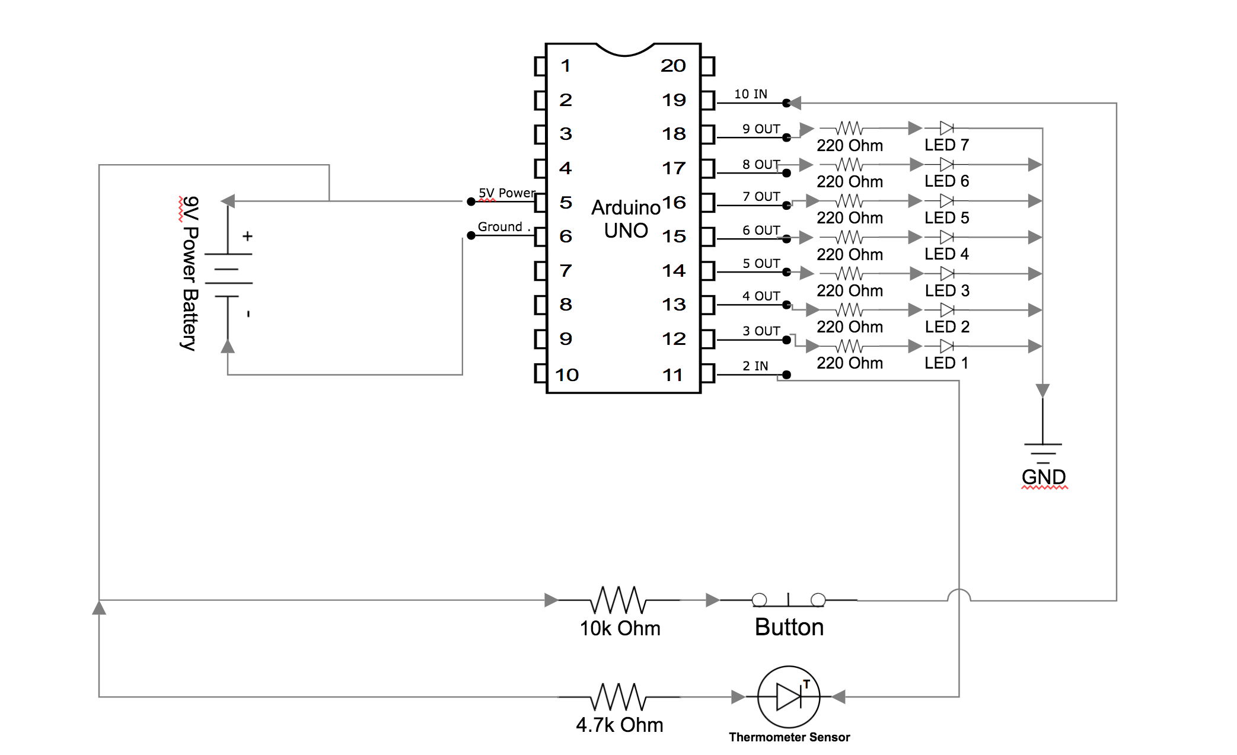

(Figure 2: The main schematic drawing of the thermometer system)

For the MCU of the system, we incorporated the [Arduino UNO](https://www.adafruit.com/product/50?gclid=CjwKCAjwu7LOBRBZEiwAQtfbGPXpZibqN0a7AwN05Z1RHYEWhW26NjofAsovchUy3OYCOZEH-FsMixoCQxsQAvD_BwE) (Figure 3) microcontroller. We chose this MCU because it was very compatible with the DS18B20 waterproof thermometer in our design. The Arduino software IDE is also simple to use and based off of the Java programming language so the logical and digital design were made easier. For this project design, the 5v and GND ports were utilised to power the breadboard of our system. We used port 2 for the data transfer of the thermometer. Ports 3-9 were used for LED control, and port 10 was used for the button press operation, which are all documented in Figure 2.

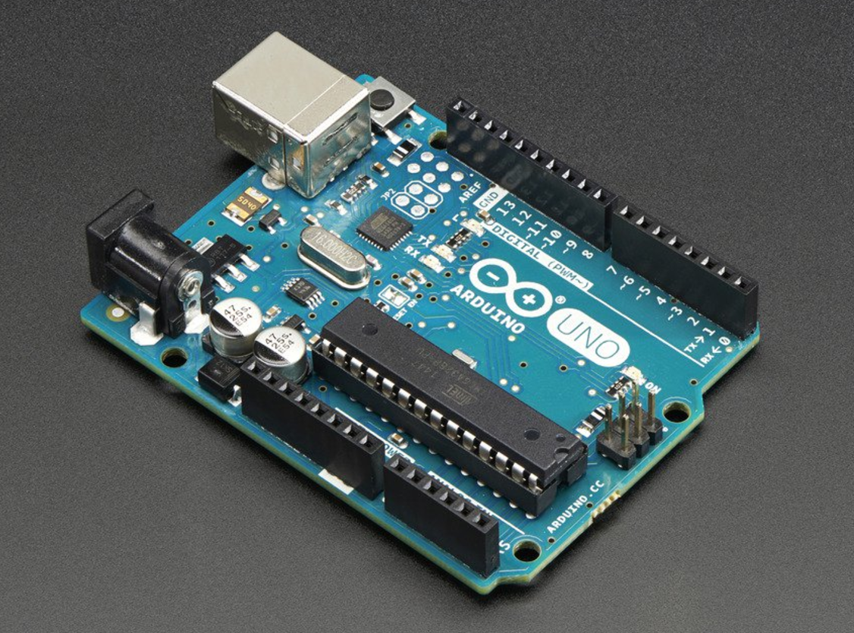 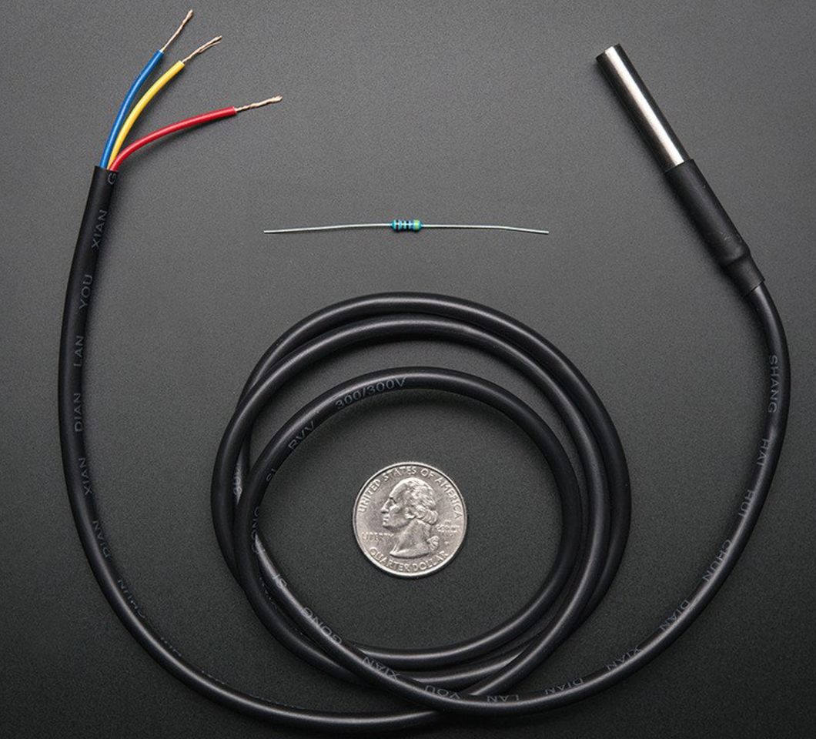

(Figure 3: The Arduino UNO MCU) (Figure 4: The DS18B20 Cable)

Connecting to the Third Box is the 2.0 meter temperature sensor cable. In our design we incorporated the [DS18B20 Waterproof cable](https://www.adafruit.com/product/381?gclid=CjwKCAjwu7LOBRBZEiwAQtfbGBvMAKah0feYz-o73161ZSSGzOgZI0C8X0KSz1C_86csigG51QkwkBoC2OQQAvD_BwE) (Figure 4) which by default is only 0.91 meters long. To extend the cable to the required 2.0 meters, you must use standard electronic wiring and solder the 5v power, ground, and data cable to extend the wiring to the required length and trim the wiring to in order to connect it to the main circuit. To waterproof the extended wiring, we used a shrinkwrap waterproof tube, and then applied heat until it sealed the cables inside and provided a complete waterproof wiring for the DS18B20.

The LED system is comprised of seven standard LEDs and seven 220 Ω resistors. The connection system is displayed on Figure 2 where each port of the MCU is connected to a resistor, then to the LED, and then to ground. The LED system operates when the button on the Third Box is pressed and held down. When held, the current temperature that is being recorded is displayed on the LEDs in 7-bit binary. This system also accounts for negative temperatures. When the button is released, the LEDs turn off. The system will also light up when a digital button on the software display is pressed.

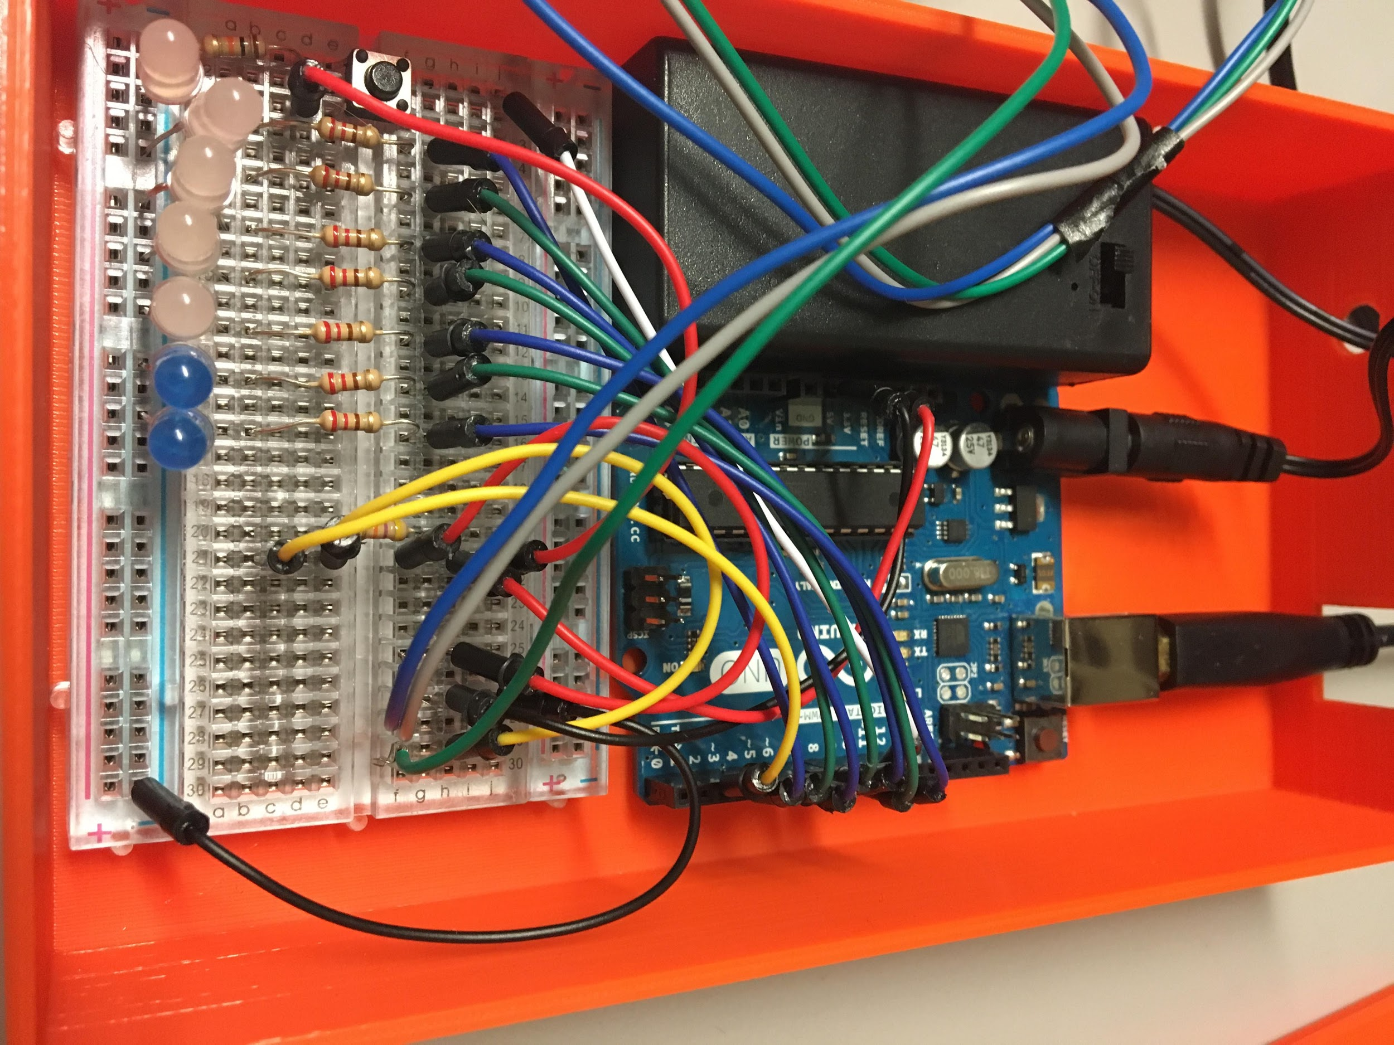 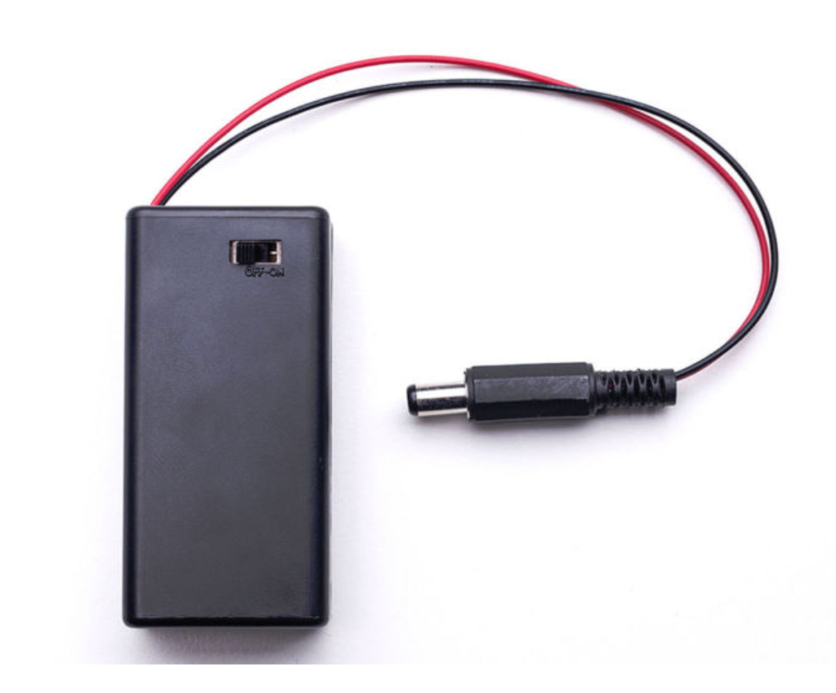

(Figure 5: The LED setup) (Figure 6: The Adafruit 9V Battery Case)

The switch component of the Third Box simply just allows battery power to be used for the system for when the data cable to the computer is disconnected, you will still be able to view the current thermometer reading in binary via the LEDs. The battery component is a [Adafruit 9V Battery Case w/ Switch and Barrel Connector](https://www.ebay.com/i/112553204737?chn=ps&dispItem=1) that uses a standard 9v battery to supply power. The cable is connected to the MCU and provides power when the switch is on.

For our third box, we decided to use a 3D-Print to make it. We can design whatever shape of third box that we want. There are a few windows that allow us to view LEDs, connect the wires and access buttons. We used a software called Rhino to design our third box. The University of Iowa’s Engineering Technology Center helped us to print the box by Makerbot 3D Printing. It is made by plastic, so it is solid enough to pass the drop test, and it will not get damaged by water or other liquids easily.

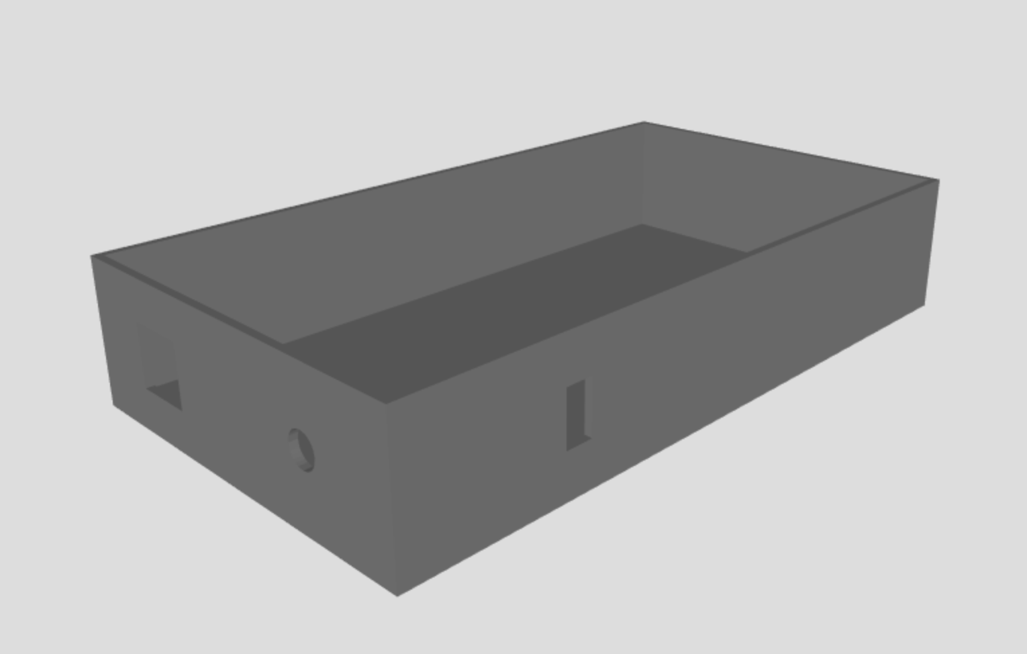

(Figure 7: The 3D Design of the housing for the Third Box)

Part List:

|  |  |  |  |
| --- | --- | --- | --- |
| Quantity: | Name: | Price: | Link: |
| 1 | Arduino UNO R3 | $24.95 | [Link](https://www.adafruit.com/product/50?gclid=CjwKCAjwu7LOBRBZEiwAQtfbGPXpZibqN0a7AwN05Z1RHYEWhW26NjofAsovchUy3OYCOZEH-FsMixoCQxsQAvD_BwE) |
| 1 | 3D Printed Housing | $30.00 | [Link](https://etc.engineering.uiowa.edu/forms/submit-files-makerbot-3d-printing) |
| 1 | Mini Transparent Solderless Breadboard 400 Contacts | $5.10 | [Link](https://www.walmart.com/ip/Mini-Transparent-Solderless-Breadboard-400-Contacts-Tie-points-Universal/163954783?wmlspartner=wlpa&selectedSellerId=11383&adid=22222222227090406777&wmlspartner=wmtlabs&wl0=&wl1=g&wl2=c&wl3=204659065569&wl4=pla-330575996380&wl5=9018505&wl6=&wl7=&wl8=&wl9=pla&wl10=117015210&wl11=online&wl12=163954783&wl13=&veh=sem) |
| 7 | 5mm LED | $0.49 | [Link](http://www.ledsupply.com/leds/5mm-led-white-15-degree-viewing-angle?gclid=CjwKCAjwu7LOBRBZEiwAQtfbGHFOjchoj23iM-xxZjrc5Ra2i_qshKjf1hK1Ftz7bVERuM5rHI6xahoC8LgQAvD_BwE) |
| 7 | 220 Ohm Resistor | $0.01 | [Link](http://www.newark.com/multicomp/mccfr0s2j0221a20/carbon-film-resistor-220-ohm-500mw/dp/58K4958?mckv=sCVfWyEsH_dc%7Cpcrid%7C81515567901%7Cplid%7C%7Ckword%7C%7Cmatch%7C%7Cslid%7C%7Cproduct%7C58K4958%7C&gross_price=true&CATCI=pla-162177930021&CAAGID=20376568341&CMP=KNC-GUSA-GEN-SHOPPING-58K4958&CAGPSPN=pla&gclid=CjwKCAjwu7LOBRBZEiwAQtfbGGVaUO-CjTq_IkAsGzpNX6KhrbYrFrH4KLapBvXA2MBbLa4_YZNwphoC1gYQAvD_BwE&DM_PersistentCookieCreated=true&CAWELAID=120185550001240171) |
| 1 | Waterproof DS18B20 | $9.95 | [Link](https://www.adafruit.com/product/381?gclid=CjwKCAjwu7LOBRBZEiwAQtfbGBvMAKah0feYz-o73161ZSSGzOgZI0C8X0KSz1C_86csigG51QkwkBoC2OQQAvD_BwE) |
| 1 | Adafruit 9V Battery Case | $3.95 | [Link](https://www.ebay.com/i/112553204737?chn=ps&dispItem=1) |
| 1 | 4 Pins DIP PCB Momentary Tactile Tact Push Button | $3.96 | [Link](https://www.amazon.com/dp/B00E1JN6SE/ref=asc_df_B00E1JN6SE5191297/?tag=hyprod-20&creative=395009&creativeASIN=B00E1JN6SE&linkCode=df0&hvadid=198090929431&hvpos=1o5&hvnetw=g&hvrand=2958153009197600385&hvpone=&hvptwo=&hvqmt=&hvdev=c&hvdvcmdl=&hvlocint=&hvlocphy=9018505&hvtargid=pla-348934955244) |
| 1 | 10k Ohm Resistor | $0.01 | [Link](https://www.amazon.com/Projects-Resistors-Watt-Choose-Quantity/dp/B071439J4B) |
| 1 | 4.7k Ohm Resistor | $0.01 | [Link](https://www.radioshack.com/products/radioshack-4-7k-ohm-1-4-watt-carbon-film-resistor-5-pack) |
| 16 | Electronic Circuit Wire | $3.95 | [Link](https://www.digikey.com/product-detail/en/825/1528-1161-ND/5353621?WT.mc_id=IQ_7595_G_pla5353621&wt.srch=1&wt.medium=cpc&WT.srch=1&gclid=CjwKCAjwu7LOBRBZEiwAQtfbGPQVCzFZGOXeYzOfdRSzYxmhZ_GhnMFBUhbQQDGklG6SpDQIwToZ9RoCn90QAvD_BwE) |